[Fiori Launchpad Catalog&Group&Role Management](http://zyndanismanlik.com/fiori-launchpad-cataloggrouprole-management/)

First of all you need to know what catalog and group is..I assume you know role management in SAP via PFCG transaction..

Catalog : set of similar Tiles(Apps) for which you can authorize users.. When you authorize a user for a catalog, it means that USER can use ALL the tiles(apps) in that catalog.

Group : set of similar Tiles(Apps) **from one or more catalogs**..When you authorize a user for a group, user can see that group of tiles(apps) in FLP Homepage..Groups can be personalized(add,edit,delete) through FLP Homepage..

So Group is not mandatory, User can create own groups and add the tiles according to his/her own will. Groups can be thought as predefined groups of apps in FLP Homepage..

Catalog&Group management is done via **FLP Designer page**..You can use the below transactions or the URLs to open Designer page..

* /UI2/FLPD_CUST : client dependent
* https://<host>:<port>/sap/bc/ui5_ui5/sap/arsrvc_upb_admn/main.html?scope=CUST
* /UI2/FLPD_CONF : client independent
* https://<host>:<port>/sap/bc/ui5_ui5/sap/arsrvc_upb_admn/main.html?scope=CONF

As example I will add two apps on catalog and group and assign to my user..

If you want to transport the catalog and groups you create, to Quality and Production systems, before you start you have to choose a **Customizing Request**

[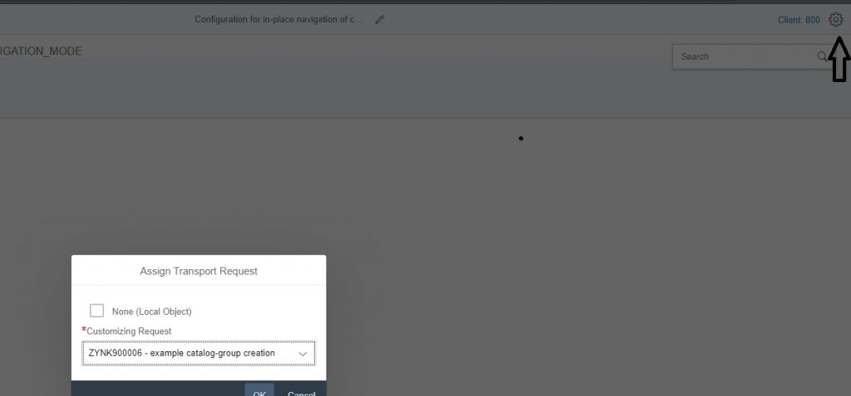](http://zyndanismanlik.com/wp-content/uploads/2019/11/1-2.png)

**Catalog Management**

In order to create a catalog click on the (+) icon and give your catalog name and ID

[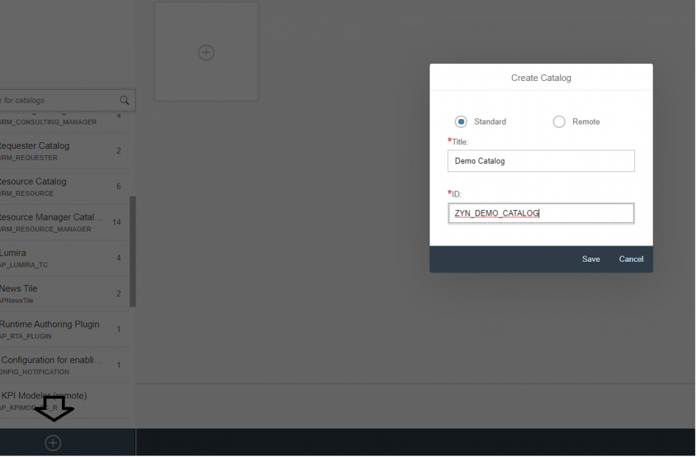](http://zyndanismanlik.com/wp-content/uploads/2019/11/2-2.png)

First you need to create Target Mapping for your app.

[metin içeren bir resim

Açıklama otomatik olarak oluşturuldu](http://zyndanismanlik.com/wp-content/uploads/2019/11/3-2.png)

In target mapping, we define :

* Semantic Object & Action : you will reference these in tile creation in next step..When the user clicks on your apps URL of the FLP will change like …/FioriLaunchpad.html#SemanticObject-Action
* URL : SICF path of the app
* ID : ID of the app, you can copy it from manifest.json

[metin, ekran görüntüsü, iç mekan içeren bir resim

Açıklama otomatik olarak oluşturuldu](http://zyndanismanlik.com/wp-content/uploads/2019/11/4-1.png)

Then go to **Tiles** tab and click on **(+)** icon select**App Launcher-Static** in order to create tile..

In this step, we fill the properties to be seen by the user in Tile in FLP.Semantic Object&Action is enough for FLP to understand which app to be opened..

[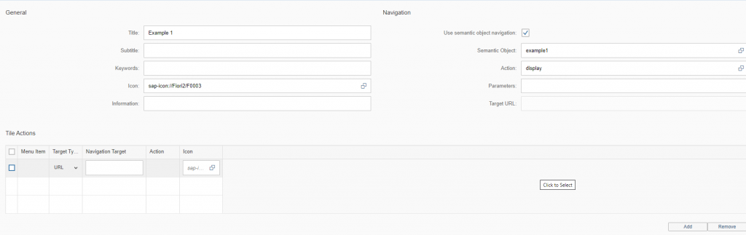](http://zyndanismanlik.com/wp-content/uploads/2019/11/5.png)

**Group Management**

Go to Groups tab and click on (+) icon to create a new Group..

[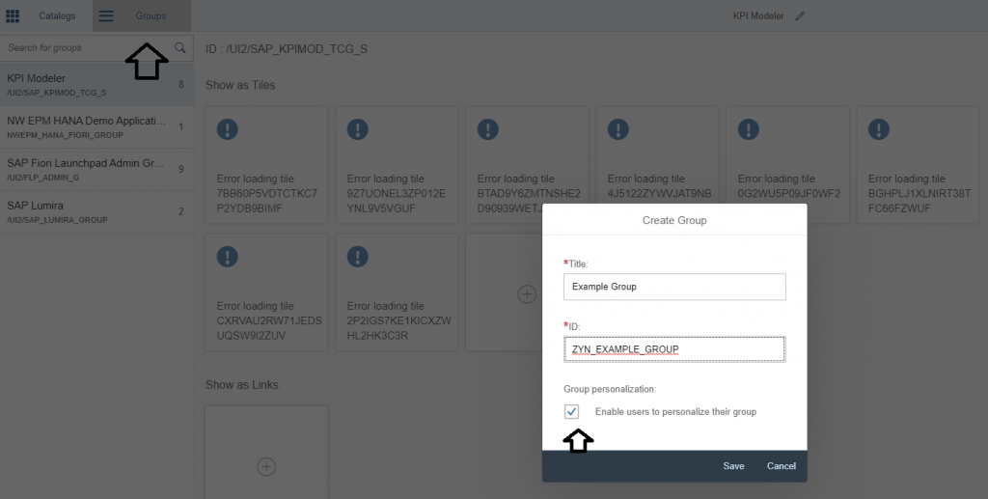](http://zyndanismanlik.com/wp-content/uploads/2019/11/6-1.png)**If you don’t want users to personalize this gorup, you can uncheck the checkbox..**

Click on (+) icon in order to add tiles to your group..

[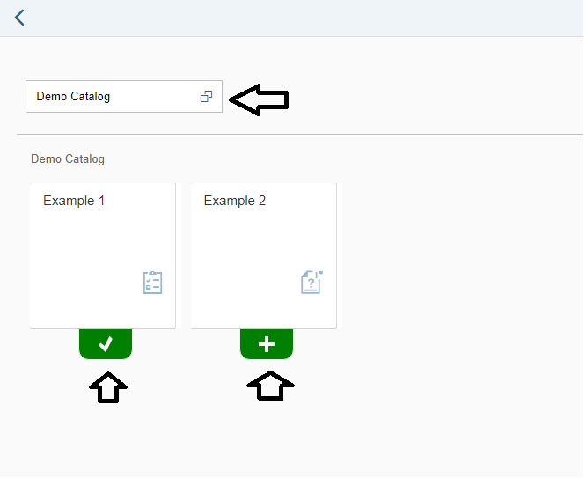](http://zyndanismanlik.com/wp-content/uploads/2019/11/7-1.png)

And the group is ready

[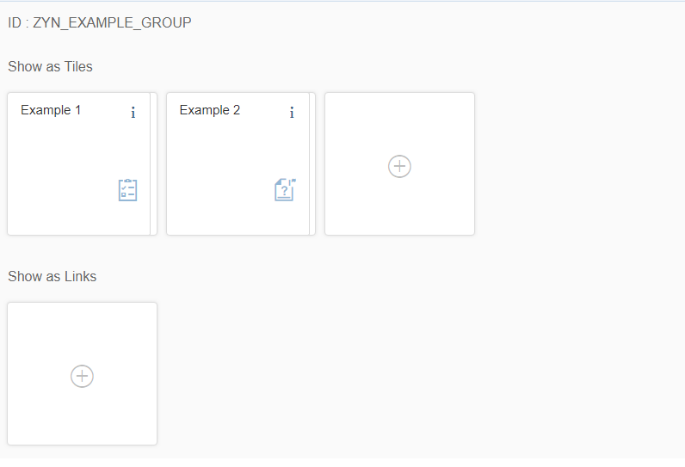](http://zyndanismanlik.com/wp-content/uploads/2019/11/8-1.png)

**Role Management**

In order to authorize user, we will add the catalog and group to a role via PFCG and assign the role to a user..

[metin içeren bir resim

Açıklama otomatik olarak oluşturuldu](http://zyndanismanlik.com/wp-content/uploads/2019/11/9-1.png)[metin içeren bir resim

Açıklama otomatik olarak oluşturuldu](http://zyndanismanlik.com/wp-content/uploads/2019/11/10-1.png)

**Conclusion**

Check your FLP

[metin, ekran görüntüsü içeren bir resim

Açıklama otomatik olarak oluşturuldu](http://zyndanismanlik.com/wp-content/uploads/2019/11/11-1.png)

And notice how the URL changes when you open an app..

[](http://zyndanismanlik.com/wp-content/uploads/2019/11/12-1.png)